Computational Based Comparison of COVID-19 Vaccine Sentiment Occupational Groups on Reddit in 2021
Abstract
Background: The success of the global COVID-19 vaccination campaign was contingent not only on supply and logistics but also on public acceptance, which was heavily influenced by online discourse. Understanding how different societal groups discuss and perceive vaccines is critical for effective public health communication.
Objective: This study aimed to analyze and compare sentiment towards COVID-19 vaccines between blue-collar and white-collar occupational communities on the social media platform Reddit during the peak of the vaccine rollout in 2021.
Methods: A purposive sampling strategy was used to select 17 profession-specific subreddits, categorized as either "blue-collar" or "white-collar." Using the Python Reddit API Wrapper (PRAW), a total of 839 relevant posts and comments containing keywords such as "vaccine," "pfizer," or "moderna" were collected from January 1, 2021, to December 31, 2021. Sentiment for each text item was classified as positive, neutral, or negative using Google's Gemini 2.5 Flash large language model, with model temperature and thinking budget set to 0 for deterministic output. These classifications were converted to a numeric scale (-1 for negative, 0 for neutral, 1 for positive). An independent samples t-test was used to compare mean sentiment scores between the two categories. A supplementary qualitative analysis was performed to explore thematic differences in discourse.
Results: The final dataset consisted of 363 items from blue-collar subreddits and 476 from white-collar subreddits. Overall, the mean sentiment score in the white-collar category (M = -0.24, 95% CI [-0.31, -0.17]) was significantly more negative than the near-neutral sentiment in the blue-collar category (M = -0.01, 95% CI [-0.10, 0.09]), a statistically significant difference (p < .001). Proportional analysis revealed that blue-collar communities had a much higher percentage of positive comments (39.9%) than white-collar communities (19.3%). However, analysis of individual subreddits revealed significant intra-category heterogeneity, challenging the meaning of the overall average. For instance, the blue-collar subreddit r/KitchenConfidential was strongly positive (M = 0.16), while r/Machinists was strongly negative (M = -0.55). Exploratory qualitative analysis indicated these differences were driven by distinct discursive frames.
Conclusion: This study reveals a significant difference in COVID-19 vaccine sentiment between online blue-collar and white-collar communities. However, the "illusion of the average" masks profound variations within these broad categories. Public health messaging must move beyond simplistic demographic targeting and instead be tailored to the specific values, concerns, and discursive frameworks of distinct occupational groups to effectively address vaccine hesitancy.
1. Introduction
The COVID-19 pandemic necessitated unprecedented vaccination efforts, but public reception was deeply fragmented. This fragmentation was influenced by a complex interplay of socioeconomic factors, political ideology, and an evolving information landscape characterized by an "infodemic" on social media (Zarocostas, 2020). Widespread vaccination was crucial for mitigating severe disease and reducing healthcare system burden, yet vaccine hesitancy—the delay in acceptance or refusal of vaccination despite availability—remained a significant threat.
In the digital age, public opinion and health-related behaviors are increasingly shaped by discourse on social media platforms. These platforms can act as powerful vectors for both factual public health information and harmful misinformation, with research demonstrating a quantifiable negative impact of exposure to online misinformation on vaccination intent (Loomba et al., 2021). Online spaces often form "echo chambers," where users are primarily exposed to information that confirms their existing beliefs, potentially polarizing discussions and hardening opposition (Barberá et al., 2015).
Occupation is a critical social determinant of health, often serving as a proxy for education, income, and exposure risk. Traditionally, literature suggests that higher socioeconomic status (SES) and education levels correlate with higher vaccine acceptance (Fisher et al., 2020). This traditional understanding frames the central paradox explored in this study: if higher SES predicts greater acceptance, one might expect white-collar professional communities to exhibit more positive sentiment. If online discourse diverges from these established patterns—for instance, if white-collar communities express higher negativity—it suggests that online behavior may differ from general population behaviors, or that the nature of the negativity requires deeper examination.
The COVID-19 pandemic presented a complex picture regarding occupational risk and vaccine acceptance. While blue-collar and essential workers often faced higher exposure risks, studies indicated varied vaccination intent within these groups, influenced by factors such as historical mistrust in institutions and localized group norms (Daly & Robinson, 2021). Furthermore, political polarization in the United States often became a stronger predictor of vaccine stance than traditional SES indicators (Fridman et al., 2021).
Crucially, the landscape of this discourse was significantly altered by the introduction of employer and government vaccine mandates in 2021. Mandates introduced a critical confounding factor into the discourse; while aimed at increasing uptake, they also galvanized opposition by shifting the focus from medical efficacy to issues of autonomy, labor rights, and government overreach (Musumeci & Kates, 2021; Hamel et al., 2022). This policy context is critical, as resistance to mandates frequently transcended occupational categories but was articulated through different frameworks—legal and procedural challenges in professional sectors, and labor disputes in trades.
While much research has focused on political ideology as a primary driver of vaccine sentiment, less is known about how occupational class influences this discourse. Blue-collar and white-collar workers face different daily realities, occupational hazards, economic pressures, and levels of trust in institutions, all of which may shape their perspectives on vaccination and related policies.
The social media platform Reddit, with its structure of distinct, topic-based communities known as "subreddits," provides a unique opportunity to study these group-specific conversations. By targeting subreddits dedicated to specific professions, it is possible to isolate and analyze the discourse within these occupational communities. This study leverages this platform to investigate the following research question: How did sentiment towards COVID-19 vaccines differ between blue-collar and white-collar occupational communities on Reddit during the 2021 vaccine rollout? By analyzing both the quantitative sentiment and the qualitative nature of the discourse, this paper aims to provide nuanced insights that can inform more targeted and effective public health communication strategies.
2. Methods
2.1. Data Source and Study Period
The data for this study were collected from the social media platform Reddit. The study period was defined as January 1, 2021, to December 31, 2021, inclusive. This 12-month period was chosen as it covers the initial rollout of COVID-19 vaccines to the general public in many Western countries, subsequent debates over mandates, and the emergence of new variants, representing a period of intense public discourse on the topic.
2.2. Subreddit Selection and Categorization
A purposive sampling strategy was employed to identify and select subreddits for analysis. The primary inclusion criterion was a clear and explicit focus on a specific profession, trade, or field of work. These identified subreddits were then classified into two broad categories based on established sociological definitions:
Blue-Collar: Subreddits representing professions that typically involve manual labor, skilled trades, or service industry work. The final list included: r/Carpentry, r/electricians, r/Construction, r/Welding, r/Plumbing, r/Machinists, r/Truckers, r/KitchenConfidential, r/ProtectAndServe, and r/Firefighting. Subreddits like r/AutoDetailing and r/Justrolledintotheshop were initially included but yielded no relevant data and were excluded from the final analysis.
White-Collar: Subreddits representing professions that are typically salaried, office-based, or require formal higher education. The final list included: r/consulting, r/cscareerquestions, r/law, r/Accounting, and r/engineering.
This sampling strategy was designed to capture discourse from distinct occupational spheres. To achieve a comparable volume of data across categories, a broader range of blue-collar subreddits was included, reflecting a potentially more fragmented online community structure for these professions compared to the larger, consolidated subreddits for professional fields like law and accounting.
2.3. Data Collection
Data were programmatically collected using the Python Reddit API Wrapper (PRAW). A search query was constructed to identify relevant content within the selected subreddits. The query searched for submissions (posts) and comments containing any of the following keywords: "vaccine", "vaccinated", "vaccination", "pfizer", "moderna", or "j&j".
The selection of these search terms was a critical and deliberate step, guided by a principle of maximizing specificity and relevance. These keywords were empirically chosen for their direct and unambiguous connection to COVID-19 vaccines, a strategy designed to minimize the inclusion of off-target discussions and ensure that every collected data point was highly pertinent to the research question.
Furthermore, this targeted approach addresses practical considerations inherent in large-scale data collection via APIs, namely the computational load and platform rate limits. Using overly broad or ambiguous search terms (e.g., "covid," "shot," "mandate") would have risked returning an unmanageably large and noisy dataset, potentially obscuring the specific sentiment towards vaccines and exceeding API usage quotas. The chosen strategy therefore represents a trade-off, prioritizing high-quality, relevant data over a larger, less focused corpus.
The collection script iterated through each target subreddit, searching for posts created within the specified 2021 date range. To ensure relevance, a two-tiered filtering process was applied: first, a post's title or body text had to contain one of the keywords. Second, for each relevant post, the script collected its associated comments, and only comments that also contained one of the keywords were retained for analysis. This process increased the likelihood, though does not guarantee, that every data point (post or comment) was related to the topic of COVID-19 vaccines. The final dataset comprised a total of 839 unique items: 363 from the blue-collar category and 476 from the white-collar category.
2.4. Sentiment Analysis
Sentiment analysis was performed using Google's Gemini 2.5 Flash, a state-of-the-art large language model (LLM). The use of a sophisticated LLM was chosen over traditional lexicon-based methods (e.g., VADER) to better capture context, nuance, and sarcasm, thereby improving classification accuracy, a strength of modern LLMs (Zhang et al., 2023).
For each text item, a specific prompt was submitted to the model:
Analyze the sentiment of the following text, and determining the text's opinion on COVID vaccinations, as to whether it has a positive sentiment towards COVID Vaccines, a negative sentiment towards COVID vaccines, or a neutral sentiment towards COVID vaccines. Return only a single word: 'positive', 'neutral', or 'negative'. Text: "[text_content]"
To ensure deterministic and reproducible outputs, the model's temperature and thinking_budget parameters were both set to 0. The model's single-word output was then mapped to a numerical scale for quantitative analysis: positive = 1, neutral = 0, and negative = -1.
2.5. Statistical and Qualitative Analysis
Descriptive statistics, including frequencies, percentages, means, and 95% confidence intervals (CI), were calculated to describe the sentiment distribution within and between categories. An independent samples t-test was conducted to determine if the difference in mean sentiment scores between the blue-collar and white-collar categories was statistically significant. The alpha level for significance was set at p < 0.05.
To supplement the quantitative results, a supplementary, exploratory qualitative analysis was conducted. This involved a thematic review of the content from key high-variance and high-volume subreddits (e.g., r/law, r/Machinists, r/KitchenConfidential) to identify and understand the underlying reasons and discursive frames driving the observed sentiment scores.
3. Results
3.1. Proportional Sentiment Distribution
The analysis of 839 comments and posts revealed distinct patterns of sentiment between the two occupational categories. As shown in Table 1 and visualized in Figure 3, the blue-collar category exhibited a substantially higher proportion of positive sentiment towards vaccines (39.9%) compared to the white-collar category (19.3%). Conversely, white-collar communities displayed a higher proportion of both neutral (37.6% vs. 19.6%) and slightly higher negative sentiment (43.1% vs. 40.5%).
Table 1: Distribution of COVID-19 Vaccine Sentiment by Occupational Category
Category | N (Total) | Positive N (%) | Neutral N (%) | Negative N (%)
white_collar | 476 | 92 (19.3%) | 179 (37.6%) | 205 (43.1%)
blue_collar | 363 | 145 (39.9%) | 71 (19.6%) | 147 (40.5%)
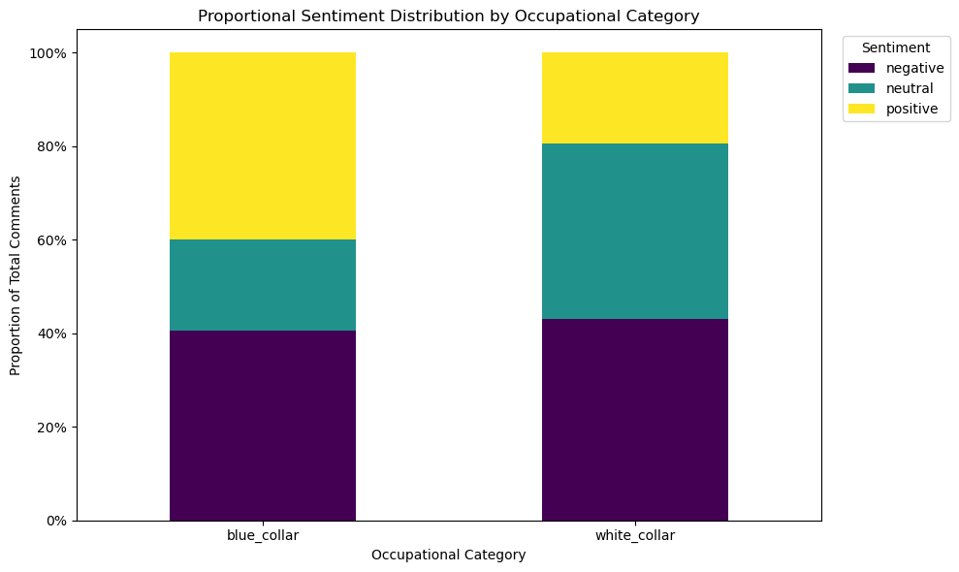
Figure 3: Proportional Sentiment Distribution by Occupational Category. This chart shows that the blue_collar category had a much larger proportion of positive comments, while the white_collar category had a larger proportion of neutral and slightly more negative comments.
3.2. Mean Sentiment Score Comparison
The conversion of sentiment to a numeric scale allowed for a direct comparison of mean sentiment. The results, summarized in Table 2 and Figure 1, show a statistically significant difference between the two groups. The mean sentiment score for the white-collar category was distinctly negative (M = -0.24, 95% CI [-0.31, -0.17]), whereas the mean score for the blue-collar category was effectively neutral (M = -0.01, 95% CI [-0.10, 0.09]). An independent samples t-test confirmed that this difference was highly significant (p = 0.000080, or p < .001). The 95% confidence interval for the white-collar group lies entirely below zero, indicating a statistically significant negative sentiment overall, while the confidence interval for the blue-collar group crosses zero, consistent with its overall neutral finding.
Table 2: Independent Samples T-Test Comparing Sentiment Scores
Group | N | Mean (95% CI) | P-Value
Blue Collar | 363 | -0.01 [-0.10, 0.09] | 0.000080
White Collar | 476 | -0.24 [-0.31, -0.17]

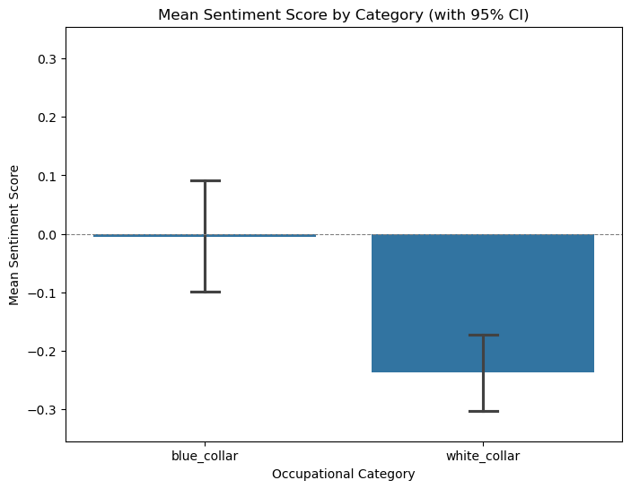
Figure 1: Mean Sentiment Score by Category (with 95% CI). The chart visually confirms the results of the t-test, showing a significantly lower mean sentiment for the white_collar category compared to the blue_collar category.
3.4. The Illusion of the Average: Intra-Category Heterogeneity
While the aggregate statistics point to clear differences, a granular analysis at the subreddit level reveals that these category-wide averages are an "illusion," masking significant and meaningful variation within each group (Figure 4 and Table 3).
In the blue-collar category, despite an overall neutral mean of -0.01, sentiment ranged from strongly positive to strongly negative. r/KitchenConfidential (n=190), a subreddit for restaurant workers, was a bastion of positive sentiment (M = 0.16, 95% CI [0.03, 0.29]). In stark contrast, r/Machinists (n=38) expressed overwhelmingly negative views (M = -0.55, 95% CI [-0.77, -0.33]).
Similarly, the overall negative sentiment in the white-collar category (M = -0.24) was not monolithic. It was heavily driven by very negative discourse in r/law (n=199, M = -0.31) and r/Accounting (n=146, M = -0.27). Meanwhile, r/cscareerquestions (n=58), a community for software developers, was nearly neutral (M = -0.05), with a confidence interval that broadly overlapped with zero.
These findings demonstrate that the broad labels of "blue-collar" and "white-collar" are insufficient to capture the nuanced views of their constituent communities.
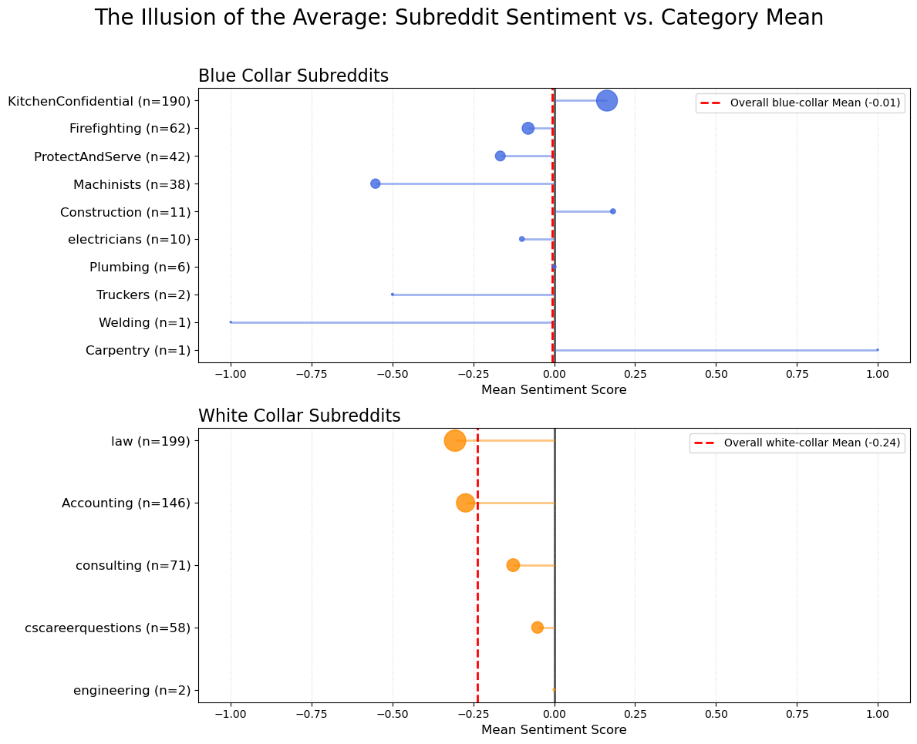
Figure 4: The Illusion of the Average: Subreddit Sentiment vs. Category Mean. This dumbbell plot highlights the dramatic variation in mean sentiment scores across individual subreddits within both the blue-collar and white-collar categories, showing how the overall category mean (dashed red line) can be a misleading summary.
Table 3: Detailed Sentiment Scores by Subreddit
Blue-Collar Subreddit
Subreddit | N | Mean [95% CI]
KitchenConfidential | 190 | 0.16 [0.03, 0.29]
Firefighting | 62 | -0.08 [-0.30, 0.14]
ProtectAndServe | 42 | -0.17 [-0.42, 0.08]
Machinists | 38 | -0.55 [-0.77, -0.33]
Construction | 11 | 0.18 [-0.40, 0.76]
electricians | 10 | -0.10 [-0.64, 0.44]
Plumbing | 6 | 0.00 [-0.72, 0.72]
Truckers | 2 | -0.50 [-1.48, 0.48]
Carpentry | 1 | 1.00 [N/A]
Welding | 1 | -1.00 [N/A]
White-Collar Subreddit
Subreddit | N | Mean [95% CI]
law | 199 | -0.31 [-0.41, -0.21]
Accounting | 146 | -0.27 [-0.41, -0.14]
consulting | 71 | -0.13 [-0.28, 0.03]
cscareerquestions | 58 | -0.05 [-0.25, 0.15]
engineering | 2 | 0.00 [0.00, 0.00]
Note: For subreddits with N=1 or 2, the Confidence Interval is Not Applicable (N/A).
3.5. Qualitative Analysis of Discursive Themes
To understand the drivers of the observed sentiment variance, an exploratory qualitative analysis was conducted. This revealed that the nature of the discourse differed significantly between communities, often reflecting profession-specific concerns and frameworks.
3.5.1. The Centrality of Mandates: Anti-Mandate vs. Anti-Vaccine
A portion of the negative sentiment across both categories was directed at coercion and employment consequences rather than the vaccine's efficacy or safety. This distinction is vital, as the negativity often reflected labor disputes or ideological objections to overreach rather than medical skepticism.
This was particularly prevalent in unionized or public service sectors, where opposition was framed as a labor rights issue. For example, in r/ProtectAndServe (Police), the discourse characterized the opposition as a contractual dispute:
Representative Example (r/ProtectAndServe, Neutral): "The media is trying to spin this as a bunch of dumb cops being against getting the vaccine. This is 100% about union and labor rights. The way the FOP sees it, the city is violating the contract... The reality is that at least 25% (probably more) of the people at risk of going into no pay status are already vaccinated."
Similar sentiments were found in trade communities, emphasizing autonomy and skepticism about employer coercion:
Representative Example (r/electricians, Negative): "Union electrician who was just informed i will be laid off tuesday if i dont get the vaccine Let me be clear. I am not an anti vaxer. I just believe in clinical trials."
3.5.2. White-Collar Discourse: Legalistic and Procedural Framing
The negativity observed in white-collar subreddits often adopted a detached, analytical frame, focusing on the legality, constitutionality, and implementation of vaccine policies.
In r/law (M = -0.31), the discourse was characterized by legal debates. Discussions frequently cited case law (e.g., Jacobson v. Massachusetts), questioned the statutory authority of regulatory bodies (like OSHA), and debated the constitutionality of mandates.
Representative Example (r/law, negative): "This will certainly end up in court. Will this Scotus hear it? Will it overturn Jacobson v. Mass. against vaccine mandates or will it overturn Wickard v. Filburn saying OSHA is outside the commerce clause?"
In r/consulting, negativity sometimes targeted the execution and logistics of vaccination programs rather than the vaccines themselves.
Representative Example (r/consulting, Negative): "44 million dollar system to track vaccinations. Deloitte pumped out some garbage that was slow and unusable."
3.5.3. Blue-Collar Discourse: Pragmatism, Risk, and Anxiety
Blue-collar discourse was more heterogeneous, reflecting diverse occupational realities.
Pro-Social and Economic Pragmatism (r/KitchenConfidential): The strongly positive sentiment in r/KitchenConfidential (M = 0.16) was framed around pragmatism, professional standards, and collective responsibility. Users argued that vaccination was necessary to keep restaurants open, protect coworkers, and ensure job security.
Representative example (r/KitchenConfidential, Positive): "If you're a chef and you give a single fuck about your craft, get the goddamn vaccine. Your food will be absolute shit when you catch covid and can't smell or taste anything..."
Occupational Risk Calculus: A notable theme in some trades was the comparison of vaccine risk to the significant daily hazards inherent in their professions. Users compared the minor risk of the vaccine to significant occupational risks (e.g., working without proper safety equipment), which tended to minimize the perceived risk of the vaccine.
Representative Example (r/Construction, Positive): "It’s pretty hilarious a bunch of Construcrion guys are worried about the safety of the vaccine but meanwhile will walk steel, weld without ventilation, bitch about the silica rules and not wear their seatbelt..."
Personal Health Anxiety Framing (r/Machinists): In stark contrast, the negativity in r/Machinists (M = -0.55) centered on specific personal health anxieties and anecdotal adverse events. A prominent thread focused on tinnitus post-vaccination, a concern highly relevant to a profession where hearing damage is an occupational hazard. This discourse was rooted in bodily integrity and fear of specific side effects.
Representative Example (r/Machinists, Negative): "developed very loud ringing after second Pfizer shot... Wouldn't have vaccinated if I knew it was going to do this. Its hell."
To understand the drivers of the observed sentiment variance, an exploratory qualitative analysis was conducted. This revealed that the nature of the discourse differed significantly between communities, often reflecting profession-specific concerns and frameworks.
Nuance in LLM Classification
The analysis reveals a limitation in the LLM classification. Though overall remarkably accurate, in certain situations sentiments towards COVID vaccines may be miscategorized. For example in polarized environments, comments that use strongly aggressive negative language are scored as negative even if the underlying attitudes towards the vaccines themselves are not negative.
Example (r/KitchenConfidential, Negative): "Preach it bro. Folk refusing to take the vaccine are, at this point, pretty much bioterrorists and businesses should refuse to employ them."
Example (r/consulting, Negative): "44 million dollar system to track vaccinations. Deloitte pumped out some garbage that was slow and unusable." (Negativity directed at implementation, not the vaccine).
4. Discussion
This study set out to compare COVID-19 vaccine sentiment between blue-collar and white-collar online communities. The results present a complex picture. On the surface, white-collar communities on Reddit were significantly more negative in their vaccine-related discourse than their blue-collar counterparts during 2021. However, the most crucial finding of this research is the "illusion of the average": these broad categorical labels conceal a vast and varied landscape of opinion, where the specific context of a profession appears to be a more powerful determinant of sentiment than its general classification.
The qualitative findings provide the necessary context to interpret the quantitative data. The negativity in r/law was not "anti-vaccine" in a medical sense but "anti-mandate" in a legal one. This is a critical distinction for public health officials. Messaging that focuses on vaccine safety and efficacy would likely be ineffective in this community, where the core concerns are constitutional and procedural. In contrast, the negativity in r/Machinists was deeply personal and rooted in specific health fears relevant to their trade (e.g., tinnitus). This suggests that messaging for this group should acknowledge these specific anxieties and provide clear information on known side effects, rather than dismissing them. The pragmatism of r/KitchenConfidential highlights a third motivator: economic and social preservation. For these workers, vaccination was a tool to protect their livelihood and their community.
These findings resonate with and extend existing literature. While Barberá et al. (2015) explored the dynamics of ideological echo chambers, our study demonstrates that profession-based communities can form their own distinct "discursive chambers," which may or may not align with broader political ideologies. The concerns driving conversation in r/law and r/Machinists, while both negative, are fundamentally different and would not be captured by a simple left-right political spectrum analysis. Furthermore, our study provides a real-world example of the types of discourse that Loomba et al. (2021) identified as influencing vaccine intent; here, the "misinformation" is not necessarily falsehood but can be context-specific anxieties and legal critiques that nonetheless contribute to a negative sentiment landscape. Our methodological approach, leveraging a state-of-the-art LLM like Gemini 2.5 Flash, aligns with the trajectory of sentiment analysis research, which increasingly values contextual understanding over simple keyword matching (Zhang et al., 2023).
4.1. Strengths, Limitations, and Future Directions
This study's primary strength lies in its two-tiered, mixed-methods approach, which successfully deconstructed a potentially misleading aggregate finding. The use of a context-aware LLM prompt for sentiment classification also represents a methodological strength over more generic tools. Nonetheless, the findings must be considered within the scope of several limitations.
Representativeness and Generalizability: The user base of Reddit is not representative of the general population**, often skewing younger and male.** Furthermore, the purposive sampling of subreddits means the findings reflect the views of active users within these specific online communities and are not generalizable to all blue-collar and white-collar workers. The small sample sizes for several subreddits (e.g., r/Welding, r/Truckers) limit the reliability of their specific mean estimates; they serve better to illustrate the overall principle of variance than as precise measurements.
Data Collection Methodology: The reliance on a specific set of keywords means the analysis is sensitive to the terminology used. Conversations about mandates or side effects that did not use the exact search terms (e.g., "vaccine," "pfizer") were not captured. The limited volume of discussion found in certain subreddits may be an artifact of this specificity. Additionally, the dataset is a snapshot of publicly available content; posts deleted by users or moderators are absent from the analysis.
LLM Classification Nuance: Sentiments may be miscategorized, particularly in the context of overly aggressive negative language, where the LLM may not inherently distinguish the target of the negativity (e.g., the vaccine vs. the mandate vs. the implementation).
Future Directions: There are several promising avenues for future research. A key next step would be to incorporate comment scores (upvotes) as a weighting factor, allowing sentiment to be measured by its level of community endorsement. Future research should also employ more advanced NLP techniques or refined prompting strategies to specifically differentiate the target of the sentiment—distinguishing clearly between attitudes towards the vaccine itself, the mandates, the implementation, or opposing ideological groups. Additionally, the qualitative analysis presented here was exploratory; a more rigorous, large-scale qualitative content analysis could systematically code and quantify the prevalence of different discursive frames (e.g., legal, personal health, economic) across all subreddits.
5. Conclusion
The discourse surrounding COVID-19 vaccines is not monolithic. This research demonstrates that while a statistically significant difference in sentiment exists between broad "blue-collar" and "white-collar" online communities, this top-level view is a misleading simplification. The true drivers of sentiment are deeply embedded in the specific contexts of individual professions, with their unique anxieties, values, and priorities. The legalistic critiques of lawyers, the health anxieties of machinists, and the pro-social pragmatism of chefs all contribute to the complex tapestry of public opinion.
The primary implication for public health is clear: one-size-fits-all communication strategies are destined to fail. To effectively build trust and encourage vaccine uptake, public health agencies must move beyond broad demographic targeting and engage in a form of "discursive listening." By understanding and addressing the specific conversational frames that dominate different communities, messaging can be tailored to be more resonant, respectful, and ultimately, more effective.
6. References
Barberá, P., Jost, J. T., Nagler, J., Tucker, J. A., & Bonneau, R. (2015). Tweeting From Left to Right: Is Online Political Communication More Than an Echo Chamber? Psychological Science, 26(10), 1531–1542. https://doi.org/10.1177/0956797615594620
Daly, M., & Robinson, E. (2021). Willingness to Vaccinate Against COVID-19 in the U.S.: Representative Longitudinal Evidence From April to October 2020. American journal of preventive medicine, 60(6), 766–773. https://doi.org/10.1016/j.amepre.2021.01.008
Fisher, K. A., Bloomstone, S. J., Walder, J., Crawford, S., Fouayzi, H., & Mazor, K. M. (2020). Attitudes Toward a Potential SARS-CoV-2 Vaccine : A Survey of U.S. Adults. Annals of internal medicine, 173(12), 964–973. https://doi.org/10.7326/M20-3569
Fridman, A., Gershon, R., & Gneezy, A. (2021). COVID-19 and vaccine hesitancy: A longitudinal study. PloS one, 16(4), e0250123. https://doi.org/10.1371/journal.pone.0250123
Hamel, L., Lopes, L., Kearney, A., & Brodie, M. (2022). KFF COVID-19 vaccine monitor: March 2021. KFF. https://www.kff.org/coronavirus-covid-19/poll-finding/kff-covid-19-vaccine-monitor-march-2021/
Loomba, S., de Figueiredo, A., Piatek, S. J., de Graaf, K., & Larson, H. J. (2021). Measuring the impact of COVID-19 vaccine misinformation on vaccination intent in the UK and USA. Nature Human Behaviour, 5, 337–348. https://doi.org/10.1038/s41562-021-01056-1
Musumeci, M., & Kates, J. (2021). Key questions about COVID-19 vaccine mandates. KFF. https://www.kff.org/coronavirus-covid-19/issue-brief/key-questions-about-covid-19-vaccine-mandates/
Zhang, W., Deng, Y., Liu, B., Pan, S. J., & Bing, L. (2023). Sentiment Analysis in the Era of Large Language Models: A Reality Check. arXiv preprint arXiv:2305.11489. https://arxiv.org/abs/2305.11489
Zarocostas J. (2020). How to fight an infodemic. Lancet (London, England), 395(10225), 676. https://doi.org/10.1016/S0140-6736(20)30461-X

